

Year 12

Physics

Sound Test

2010

Name _________________________________________________________

Score ______________________________________________/ 40 marks

Refer to constants sheet for all numerical constants

Show all working out for numerical answers accurate to 3 significant figures.

2 marks are purely allocated to significant figures.

- A teacher is writing a text book. They are trying to publish two sets of waves. One wave set is of an ordinary (propagating) sound wave and the other wave set is of a standing wave. The teacher has not put titles on the different sets and is becoming confused as to which is which. Both waves have identical specifications except one is standing and the other is propagating. These waves are not necessarily in air.
Time  (s) | Set A | Set B
t = 0 | 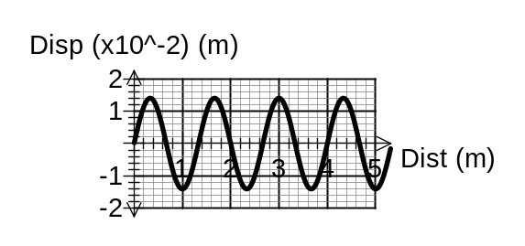
t = 0.2 | 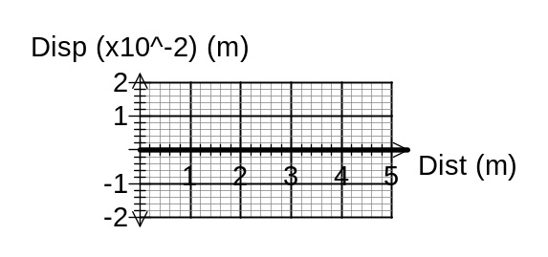 | 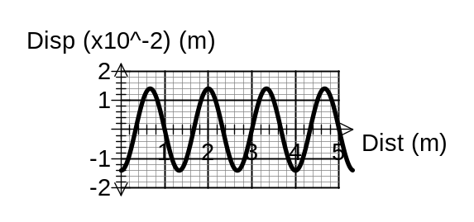
t = 0.4 | 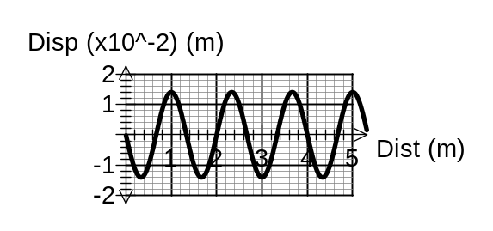
t = 0.6 |  | 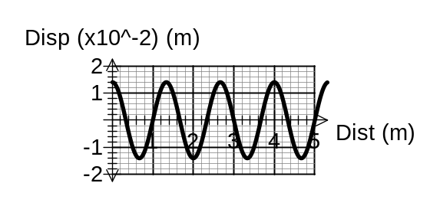
t = 0.8

Question 1 continued …

a) Which set of diagram shows a standing wave?
(1 mark)
Set A Set B (please circle one only)

b) What is the wavelength of Set B?
(1 mark)

c) If each graph in the above sets is taken 0.2 s apart, what is the period of the wave in Set B?
(1 mark)

d) What is the frequency?
(1 mark)

e) What is the velocity?
(1 mark)

f) What is the amplitude of the wave in Set B?
(1 mark)

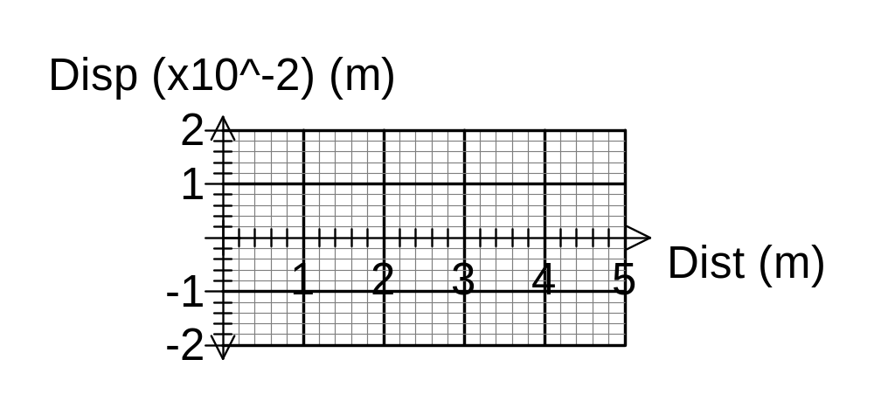g) For the set that shows the standing wave, draw the combined standing wave form.
(1 mark)

2. A didgeridoo player is blowing the fundamental note on a 1.3 m long pipe.

a) What is the fundamental wavelength?
(1 mark)

b) What is the fundamental frequency?
(2 marks)

c) The player now tightens his lips and plays the 4th harmonic of the pipe. What it the frequency that is produced?
(1 mark)

d) Draw the standing wave produced in the pipe at the fourth harmonic
(2 marks)

e) What overtone is this?
(1 mark)

f) Could this harmonic be produced on the same length of pipe if the far open end is closed with a hard plastic cap? Explain.
(2 marks)

3. A father is rinsing his 3 year old child’s hair. The child is floating face up in the bath with their ears underwater. When the child’s hair is rinsed of shampoo, the father calls to the child to sit up in the bath. The sound from the father has to pass from the air into the water.

a) What is the name of the phenomena of sound travelling from on medium into another?
(1 mark)
________________________________________________________

b) Draw the path taken by the sound wave in the water and the relative wavelength.
(2 marks)
Air
Water
c) Explain why the sound wave took its direction in the water.
(2 marks)

d) Will the fathers voice sound higher, lower or the same pitch to the child’s ears underwater. Explain
(2 marks)

4. An arrow is shot from a bow. The sound emitted from the 0.950 m long bow string is 320 Hz. What is the speed of the wave in the string?
(3 marks)

5. Two electric toothbrushes are switched on at the same time. When the sounds from the toothbrushes mix, there are 6 fluctuations in the loudness of the resultant wave each second. The instructions that came with the toothbrushes states that when fully charged the toothbrush will vibrate with a frequency of 3500 RPM. If the first toothbrush is fully charged what is the frequency of the second toothbrush in RPM?
(4 marks)

6. A Mr. Whippy van is playing some very annoying music. When the van is
1.00 km away the sound form the vans speaker is 1.00 x 10⁻⁷ W m⁻². What is the intensity of the music when you are standing 2.00 m from the speaker when purchasing an ice cream? Note - the ground is a perfect absorber.
(4 marks)

7. A remote control airplane has an engine that produces a frequency of 600 Hz. The airplane now flies towards you at 108 km h⁻¹.

a) How has the frequency of the sound you hear altered?
(1 mark)

b) Calculate the new frequency.
(3 marks)

End of Sound Test

Year 12

Physics

Sound Test
Answers

2010

Name _________________________________________________________

Score ______________________________________________/ 40 marks

Refer to constants sheet for all numerical constants

Show all working out for numerical answers accurate to 3 significant figures.

2 marks are purely allocated to significant figures.

- A teacher is writing a text book. They are trying to publish two sets of waves. One wave set is of an ordinary (propagating) sound wave and the other wave set is of a standing wave. The teacher has not put titles on the different sets and is becoming confused as to which is which. Both waves have identical specifications except one is standing and the other is propagating. These waves are not necessarily in air.
Time  (s) | Set A | Set B
t = 0
t = 0.2
t = 0.4
t = 0.6
t = 0.8

Question 1 continued …

a) Which set of diagram shows a standing wave?
(1 mark)
Set A Set B (please circle one only)

b) What is the wavelength of Set B?
(1 mark)
Reading off the graph, 3 waves fit in 4 m.

λ = 4 / 3 = 1.33 m

c) If each graph in the above sets is taken 0.2 s apart, what is the period of the wave in Set B?
(1 mark)
One complete cycle takes 0.8 s

T = 0.800 s

d) What is the frequency?
(1 mark)
f = 1 / T

f = 1 / 0.8

f = 1.25 Hz

e) What is the velocity?
(1 mark)

v = f x λ
v = 1.25 x 1.33
v = 1.67 m s⁻¹

f) What is the amplitude of the wave in Set B?
(1 mark)
1.40 x 10⁻² m

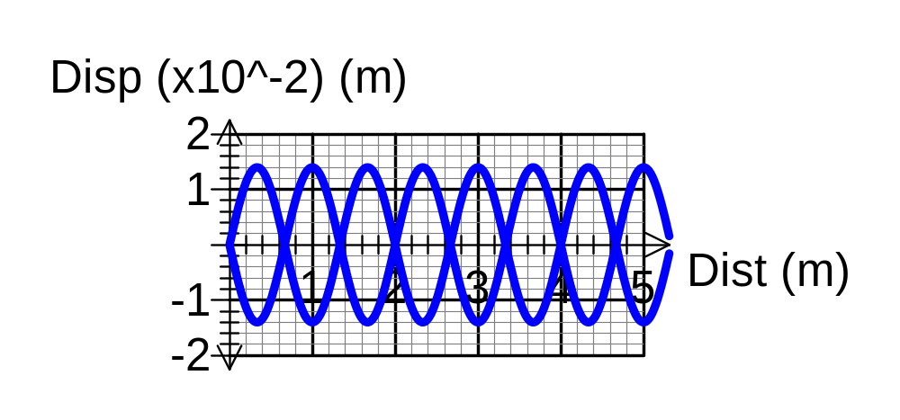g) For the set that shows the standing wave, draw the combined standing wave form.
(1 mark)

2. A didgeridoo player is blowing the fundamental note on a 1.3 m long pipe.

a) What is the fundamental wavelength?
(1 mark)
λ = 2 x L / n
λ = 2 x 1.3 / 1
λ = 2.60 m

b) What is the fundamental frequency?
(2 marks)
f = n v / 2L

f = 1 x 346 / 2 x 1.3

f = 133 Hz

c) The player now tightens his lips and plays the 4th harmonic of the pipe. What it the frequency that is produced?
(1 mark)
f₄ = f₁ x 4

f₄ = 532 Hz

d) Draw the standing wave produced in the pipe at the fourth harmonic
(2 marks)

e) What overtone is this?
(1 mark)
3rd overtone

f) Could this harmonic be produced on the same length of pipe if the far open end is closed with a hard plastic cap? Explain.
(2 marks)

No. Closed pipes can only produce the odd numbered harmonics.

Even numbered harmonics require 2 nodes or 2 antinodes to be present at the ends of the pipes.

3. A father is rinsing his 3 year old child’s hair. The child is floating face up in the bath with their ears underwater. When the child’s hair is rinsed of shampoo, the father calls to the child to sit up in the bath. The sound from the father has to pass from the air into the water.

a) What is the name of the phenomena of sound travelling from on medium into another?
(1 mark)
Refraction

b) Draw the path taken by the sound wave in the water and the relative wavelength.
(2 marks)
Air
Water

c) Explain why the sound wave took its direction in the water.
(2 marks)
The sound has changed the medium that it was travelling in.

This caused the sound wave to change speed.

Because the wave was incident at the interface (boundary) at an angle other than 0⁰ degrees with the normal, this caused the wave to change direction.

d) Will the fathers voice sound higher, lower or the same pitch to the child’s ears underwater. Explain
(2 marks)

The father’s voice will have the same frequency above and below the water. Wavelength and speed change but frequency does not.

4. An arrow is shot from a bow. The sound emitted from the 0.950 m long bow string is 320 Hz. What is the speed of the wave in the string?
(3 marks)

f = n v / 2L

320 = 1 x v / 2 x 0.95

v = 320 x 2 x 0.95

v = 608 m s⁻¹

5. Two electric toothbrushes are switched on at the same time. When the sounds from the toothbrushes mix, there are 6 fluctuations in the loudness of the resultant wave each second. The instructions that came with the toothbrushes states that when fully charged the toothbrush will vibrate with a frequency of 3500 RPM. If the first toothbrush is fully charged what is the frequency of the second toothbrush in RPM?
(4 marks)

f₁ = 3500 / 60

f₁ = 58.3333333 Hz

f_{beats} = | f₁ – f₂ |

6 = | 58.333 – f₂ |

f₂ = 64.33333Hz or 52.33333 Hz

f₂ = the lower one because the batteries are going flat …. 52.33333 Hz

f₂ = 52.33333 Hz is 3140 RPM. (3.14 x 10³ RPM) (3 sig fig)

6. A Mr. Whippy van is playing some very annoying music. When the van is
1.00 km away the sound form the vans speaker is 1.00 x 10⁻⁷ W m⁻². What is the intensity of the music when you are standing 2.00 m from the speaker when purchasing an ice cream? Note - the ground is a perfect absorber.
(4 marks)

1000 m | 2.00 m
I = P / 4πr²  1 x 10⁻⁷ = P / 4πr²  1 x 10⁻⁷ x 4πr² = P  P = 1.257 W | I = 1.257 / 4π 2.00²  I = 1.257 / 4π 2.00²  I = 0.0250 W m⁻²

7. A remote control airplane has an engine that produces a frequency of 600 Hz. The airplane now flies towards you at 108. km h⁻¹.

a) How has the frequency of the sound you hear altered?
(1 mark)
The frequency of the sound is higher (larger).

b) Calculate the new frequency.
(3 marks)
v_{s} = 108 km h⁻¹ = -30 m s⁻¹

f_{L} / (v + v_{L}) = f_{o} / (v + v_{s})

f_{L} / (346 + 0) = f_{o} / (346 -30)

f_{L} = (346 / 314) x 600

f_{L} = (346 / 314) x 600

f_{L} = 657 Hz

End of Sound Test

